CS1555 Assignment6
Group 5
Members:
Siming Zheng - siz11
Martin Kennedy - mik91

- Functional dependencies:
b->de, e->d, c->de, c->f, ab->e, df->a, dc->a, cd->e, ef->d, abe->ed
  - Using synthesis approach, construct a set of 3NF/BCNF relationship
  - canonial form:
    - b->d,
    - b->e,
    - e->d,
    - c->d,
    - c->e,
    - c->f,
    - ab->e,
    - df->a,
    - dc->a,
    - cd->e,
    - ef->d,
    - abe->e,
    - abe->d
  - drop extraneous attributes:
    - remove ab->e due to b->e;
    - remove cd->e due to c->e;
    - remove ef->d due to e->d;
    - remove abe->e due to b->e;
    - remove abe->d due to e->d;
    - b->d
    - b->e
    - e->d
    - c->d
    - c->e
    - c->f
    - df->a
    - dc->a
  - drop redundant FDs
    - b->e, e->d implies b->d
    - c->d, dc->a implies c->a
  - final FDs
    - b->e
    - e->d
    - c->d
    - c->e
    - c->f
    - df->a
    - c->a
  - primary key: bc
    - bc+: bc->bcd(c->d);
    - bcd->bcde(b->e);
    - bcde->bcdef(c->f);
    - bcdef->abcdef(c->a);
  - 3NF relationship
    - b->e
    - e->d
    - c->adef
    - df->a
    - R1(b, e)
    - R2(e, d)
    - R3(c, a, d, e, f)
    - R4(df, a)
    - R5(b, c)
  - BCNF
    - R(a, b, c, d, e, f)
    - apply b->e, R1(a, b, c, d, f) in 1NF, R2(b, e) in BCNF
    - apply e->d, R3(e, d) in BCNF,
    - apply c->adef, R4(c, a, d, e, f) in BCNF,
    - apply df->a, R11(b, c) in BCNF, R5(d, f, a) in BCNF

  - a
b1.
 | a | b | c | d | e | f
R1(b, e) | u11 | a2 | u13 | u14 | a5 | u16
R2(e, d) | u21 | u22 | u23 | a4 | a5 | u26
R3(c, a, d ,e f) | a1 | u32 | a3 | a4 | a5 | a6
R4(df, a) | a1 | u42 | u43 | a4 | u45 | a6
R5(b, c) | u51 | a2 | a3 | u54 | u55 | u56

b2. use b-> e
 | a | b | c | d | e | f
R1(b, e) | u11 | a2 | u13 | u14 | a5 | u16
R2(e, d) | u21 | u22 | u23 | a4 | a5 | u26
R3(c, a, d ,e f) | a1 | u32 | a3 | a4 | a5 | a6
R4(df, a) | a1 | u42 | u43 | a4 | u45 | a6
R5(b, c) | u51 | a2 | a3 | u54 | a5 | u56

b3. use e->d
 | a | b | c | d | e | f
R1(b, e) | u11 | a2 | u13 | a4 | a5 | u16
R2(e, d) | u21 | u22 | u23 | a4 | a5 | u26
R3(c, a, d ,e f) | a1 | u32 | a3 | a4 | a5 | a6
R4(df, a) | a1 | u42 | u43 | a4 | u45 | a6
R5(b, c) | u51 | a2 | a3 | a4 | a5 | u56

b4. use c->adef
 | a | b | c | d | e | f
R1(b, e) | u11 | a2 | u13 | a4 | a5 | u16
R2(e, d) | u21 | u22 | u23 | a4 | a5 | u26
R3(c, a, d ,e f) | a1 | u32 | a3 | a4 | a5 | a6
R4(df, a) | a1 | u42 | u43 | a4 | u45 | a6
R5(b, c) | a1 | a2 | a3 | a4 | a5 | a6

R5 contains all known values, the decomposition is lossless

2.
FD1: BookISBN -> Title, PublisherName, Price, QuantityOnHand
FD2: OrderNumber -> OrderDate, SupplierCode
FD3: SupplierCode -> SupplierName, SupplierAddress
FD4: BookISBN, OrderNumber -> QuantityOrdered

a1. BookISBN and OrderNumber does not appear on the right hand side of Fps
primary key: BookISBN, OrderNumber+:
  - BookISBN, OrderNumber, Title, PublisherName, Price, QuantityOnHand (BookISBN -> Title, PublisherName, Price, QuantityOnHand)
  - BookISBN, OrderNumber, Title, PublisherName, Price, QuantityOnHand, OrderDate, SupplierCode (OrderNumber -> OrderDate, SupplierCode)
  - BookISBN, OrderNumber, Title, PublisherName, Price, QuantityOnHand, OrderDate, SupplierCode, SupplierName, SupplierAddress (SupplierCode -> SupplierName, SupplierAddress)
  - BookISBN, OrderNumber, Title, PublisherName, Price, QuantityOnHand, OrderDate, SupplierCode, SupplierName, SupplierAddress, QuantityOrdered (BookISBN, OrderNumber -> QuantityOrdered)
a2. 3NF:
R1 (BookISBN, Title, PublisherName, Price, QuantityOnHand)
R2 (OrderNumber, OrderDate, SupplierCode)
R3 (SupplierCode, SupplierName, SupplierAddress)
R4 (BookISBN, OrderNumber, QuantityOrdered)

a3. BCNF:
R (BookISBN, OrderNumber, Title, PublisherName, Price, QuantityOnHand, OrderDate, SupplierCode, SupplierName, SupplierAddress, QuantityOrdered)
- apply BookISBN -> Title, PublisherName, Price, QuantityOnHand,
  - R1(BookISBN, OrderNumber, OrderDate, SupplierCode, SupplierName, SupplierAddress, QuantityOrdered) in 1NF;
  - R2(BookISBN, Title, PublisherName, Price, QuantityOnHand) in BCNF
- apply OrderNumber -> OrderDate, SupplierCode
  - R11(BookISBN, OrderNumber,SupplierName, SupplierAddress, QuantityOrdered) in 1NF
  - R3(OrderNumber, OrderDate, SupplierCod) in BCNF
- apply SupplierCode -> SupplierName, SupplierAddress
  - R111(BookISBN, OrderNumber, QuantityOrdered) in BCNF
  - R4(SupplierCode, SupplierName, SupplierAddress)

(part b in the next page)

b1.
 | BookISBN | OrderNumber | Title | PublisherName | Price | QuantityOnHand | OrderDate | SupplierCode | SupplierName | SupplierAddress | QuantityOrdered
R1 (BookISBN, Title, PublisherName, Price, QuantityOnHand) | a1 | u12 | a3 | a4 | a5 | a6 | u17 | u18 | u19 | u | u
R2 (OrderNumber, OrderDate, SupplierCode) | u21 | a2 | u23 | u24 | u25 | u26 | a7 | a8 | u29 | u | u
R3 (SupplierCode, SupplierName, SupplierAddress) | u31 | u32 | u33 | u34 | u35 | u36 | u37 | a8 | a9 | a10 | u
R4 (BookISBN, OrderNumber, QuantityOrdered) | a1 | a2 | u43 | u44 | u45 | u46 | u47 | u48 | u49 | u | a11

b2. apply BookISBN -> Title, PublisherName, Price, QuantityOnHand
 | BookISBN | OrderNumber | Title | PublisherName | Price | QuantityOnHand | OrderDate | SupplierCode | SupplierName | SupplierAddress | QuantityOrdered
R1 (BookISBN, Title, PublisherName, Price, QuantityOnHand) | a1 | u12 | a3 | a4 | a5 | a6 | u17 | u18 | u19 | u | u
R2 (OrderNumber, OrderDate, SupplierCode) | u21 | a2 | u23 | u24 | u25 | u26 | a7 | a8 | u29 | u | u
R3 (SupplierCode, SupplierName, SupplierAddress) | u31 | u32 | u33 | u34 | u35 | u36 | u37 | a8 | a9 | a10 | u
R4 (BookISBN, OrderNumber, QuantityOrdered) | a1 | a2 | a3 | a4 | a5 | a6 | u47 | u48 | u49 | u | a11

b3. apply OrderNumber -> OrderDate, SupplierCode
 | BookISBN | OrderNumber | Title | PublisherName | Price | QuantityOnHand | OrderDate | SupplierCode | SupplierName | SupplierAddress | QuantityOrdered
R1 (BookISBN, Title, PublisherName, Price, QuantityOnHand) | a1 | u12 | a3 | a4 | a5 | a6 | u17 | u18 | u19 | u | u
R2 (OrderNumber, OrderDate, SupplierCode) | u21 | a2 | u23 | u24 | u25 | u26 | a7 | a8 | u29 | u | u
R3 (SupplierCode, SupplierName, SupplierAddress) | u31 | u32 | u33 | u34 | u35 | u36 | u37 | a8 | a9 | a10 | u
R4 (BookISBN, OrderNumber, QuantityOrdered) | a1 | a2 | a3 | a4 | a5 | a6 | a7 | a8 | u49 | u | a11

b4. apply SupplierCode -> SupplierName, SupplierAddress

 | BookISBN | OrderNumber | Title | PublisherName | Price | QuantityOnHand | OrderDate | SupplierCode | SupplierName | SupplierAddress | QuantityOrdered
R1 (BookISBN, Title, PublisherName, Price, QuantityOnHand) | a1 | u12 | a3 | a4 | a5 | a6 | u17 | u18 | u19 | u | u
R2 (OrderNumber, OrderDate, SupplierCode) | u21 | a2 | u23 | u24 | u25 | u26 | a7 | a8 | u29 | u | u
R3 (SupplierCode, SupplierName, SupplierAddress) | u31 | u32 | u33 | u34 | u35 | u36 | u37 | a8 | a9 | a10 | u
R4 (BookISBN, OrderNumber, QuantityOrdered) | a1 | a2 | a3 | a4 | a5 | a6 | a7 | a8 | a9 | a10 | a11

R4 contains all known values, it is lossless and is a good one
3.
a) This is the clean version of the diagram (with none of the extraneous, non-key information)

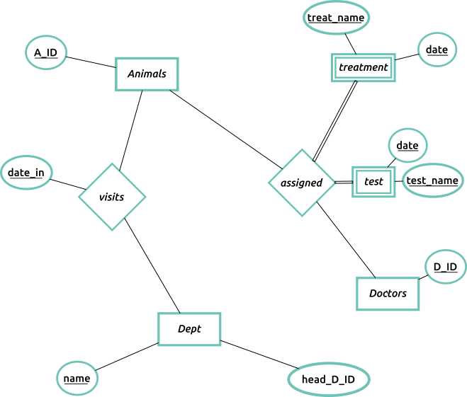
… and this is the version of the diagram with the extraneous attributes included:
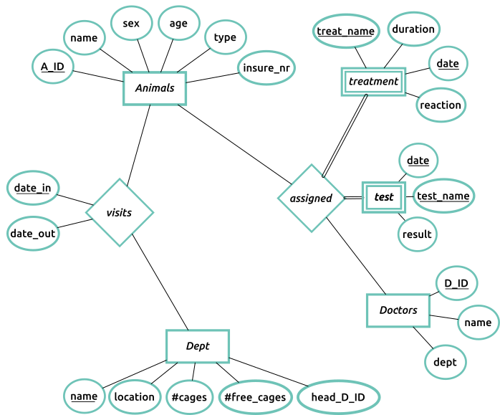

b) Note: primary keys are underlined.
Animals(A_ID, name, sex, age, type, insure_nr)

Visits(A_ID, date_in, date_out, name)
FK(A_ID, date_in) -> Animals(A_ID)

Department(name, location, cages, free_cages, head_Doc_ID)
FK(head_Doc_ID) -> Doctors(Doc_ID)

Assignments(A_ID, Doc_ID)
FK(A_ID) → Animals(A_ID)
FK(Doc_ID) → Doctors(Doc_ID)

Treatments(A_ID, authorized_by, treat_name, date, duration, reaction)
FK(A_ID) -> Animals(A_ID)
FK(authorized_by) -> Doctors(Doc_ID)

Tests(A_ID, authorized_by, test_name, date, result)
FK(A_ID) -> Animals(A_ID)
FK(authorized_by) -> Doctors(Doc_ID)

Doctors(Doc_ID, name, dept)
FK(dept) -> Department(name)

Assumptions:
- Each department has one head doctor
- The same animal can be admitted or discharged multiple times in the same day
- A test or treatment can be administered more than once in a given day.
- An animal may visit different departments, but can only be in one department at any given time

